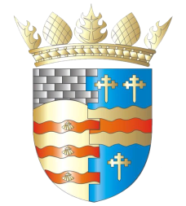**BLAIRGOWRIE AND RATTRAY COMMUNITY COUNCIL**

**Ordinary Meeting – Draft Agenda**

**Thursday, 9th January 2025, at 7pm**

**at the BaRI Building, High Street, Blairgowrie,**

**and online via Zoom**

1. Welcome and Introductions

2. Apologies

3. Adoption of draft minutes of 14th November 2024 meeting  
 4. Police & Fire Reports

5. Matters raised by members of the public

a) Elm Drive Traffic

6. Regular reports

a) Resilience/Flooding PR/SM

b) Climate Action DC/GP/JM

c) Twinning GP/SM/DC/AS

d) Maintenance in Blairgowrie & Rattray

i. Built Environment a) Electrical Connections at Wellmeadow

ii. Open Spaces

e) Local Place Plan

7. Matters Arising/Reports Back

a) Noticeboards

b) B&R Common Good Fund

c) Cherry Trees at Piggy Lane

d) First Responders in B&R

e) Scalable Cities

8. Traffic Matters

9. Planning Matters

10. Chair’s Report

11. Treasurer’s Report

12. Secretary’s Correspondence

13. Councillors’ Reports

14. AOCB

Please note: With the permission of all attendees, the minute taker will record this meeting solely for the purpose of writing up the minutes, will not share the recording, and will delete the recording as soon as the minutes have been written. The Chair will ask for permission at the start of the meeting.

Awaiting new information: CCTV, Representation of Young People, Community Action Plan, Football Pitch, Citizen of The Year

**Next meeting: Ordinary Meeting, Thursday, 13th Febrary 2025, 7.00pm**